Bulletin or Newsletter Announcement:
SMALL CHURCHES. BIG IMPACT. Broadview’s September/October Small Church special issue celebrates the strength, creativity and impact of small churches across Canada. Order copies or honour a small church or leader who shaped your life through a special Honour Roll in the issue.
Pre-order and Honour Roll deadline: July 10.
Learn more, order or donate for Honour Roll at: broadview.org/small-churches

Social Media:
Small churches shape lives in extraordinary ways. They baptize, comfort, celebrate, mourn, feed, visit and quietly hold communities together. This September/October, Broadview’s Small Church special issue will celebrate the strength, creativity and impact of small churches across Canada.
You can be part of it: order copies for yourself, your congregation or honour a small church or leader who made a difference in your life through our special Honour Roll.
📅 Pre-order and Honour Roll Deadline: July 10
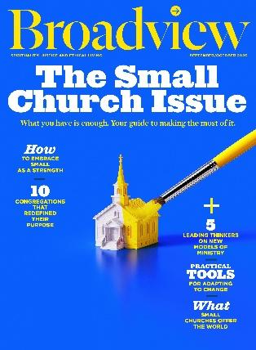
🔗 Learn more: broadview.org/small-churches

Cover Graphic:

